**Case study on Games Exercise**

**Quality checks and profiling(Using Talend)**

**3) A)** Finding null values and replace them

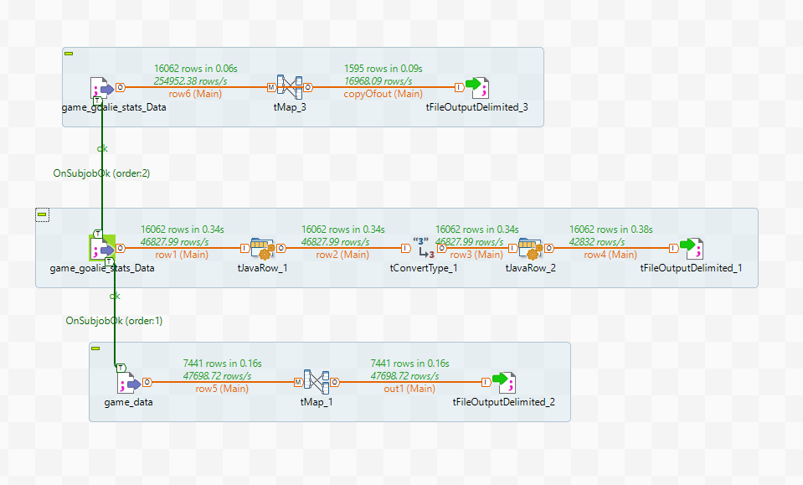

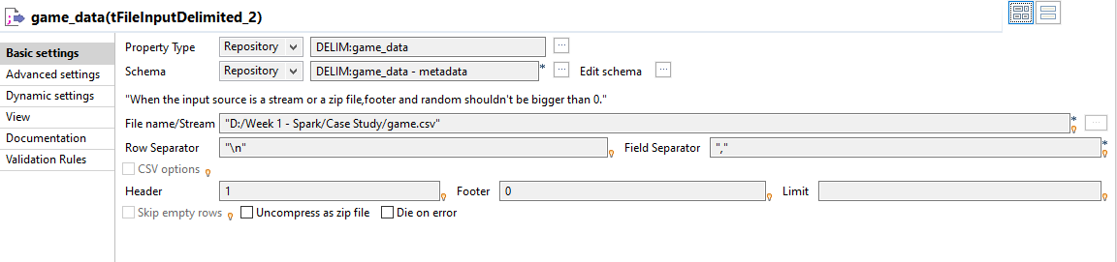

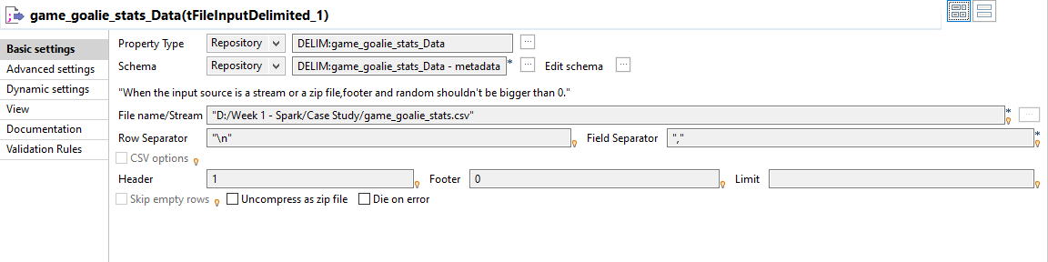

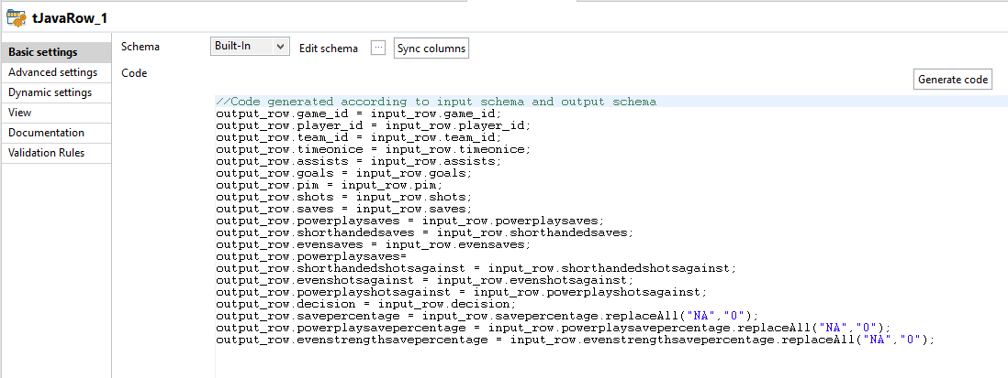

**3) b)** Round off decimal values up to 2 places

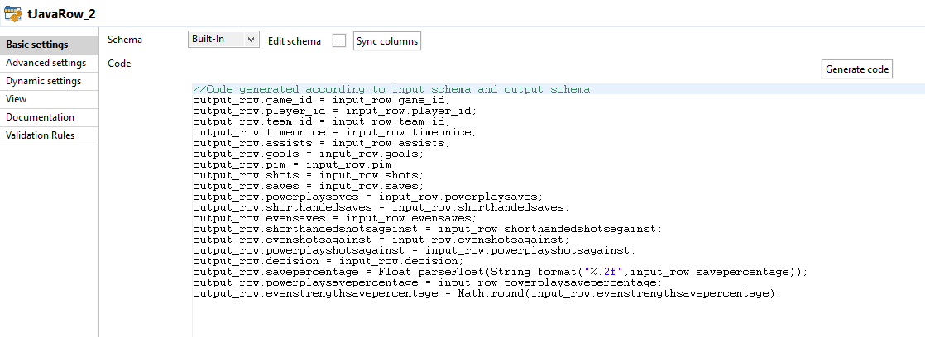

**4) Standardization (Date, Number)**

**4) A)** Convert dates to “dd-mm-yyyy hh:mm:ss” format

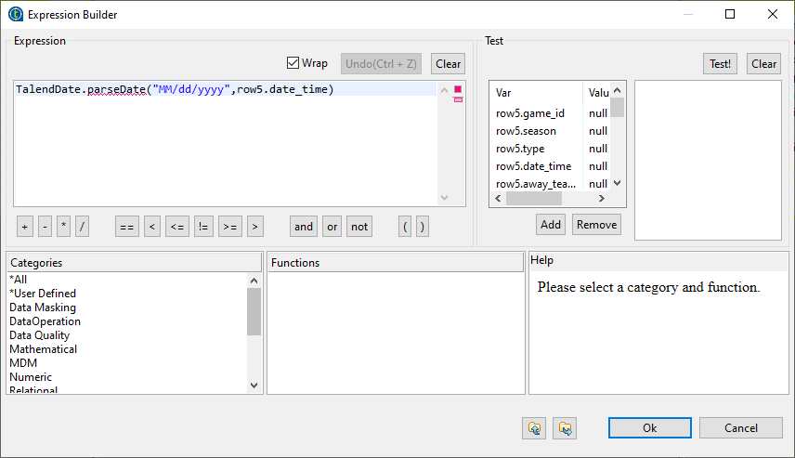

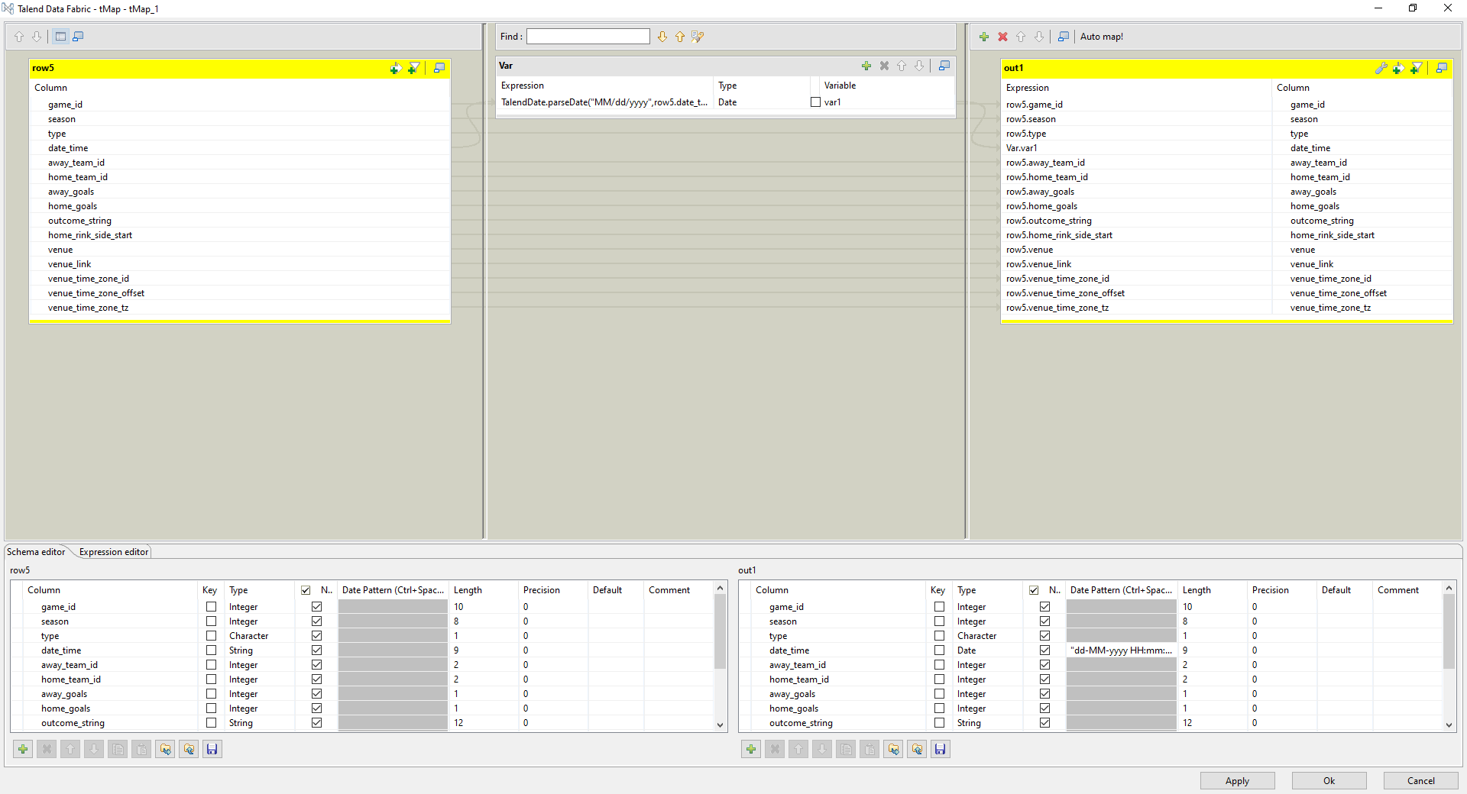

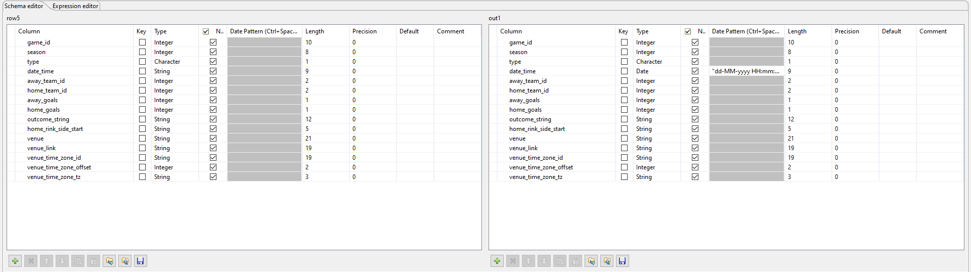

**4) B**) Convert float to integer

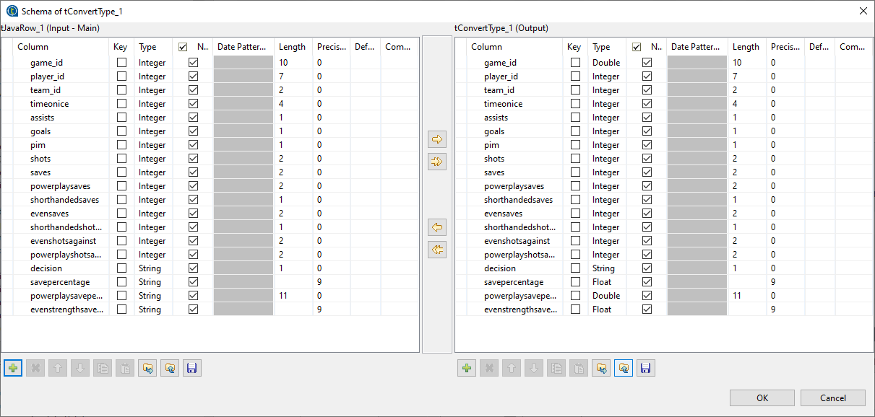

**Sending the null value records to separate file**

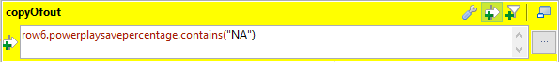

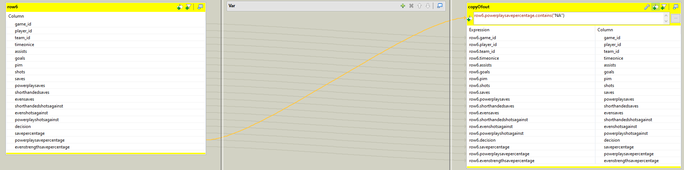

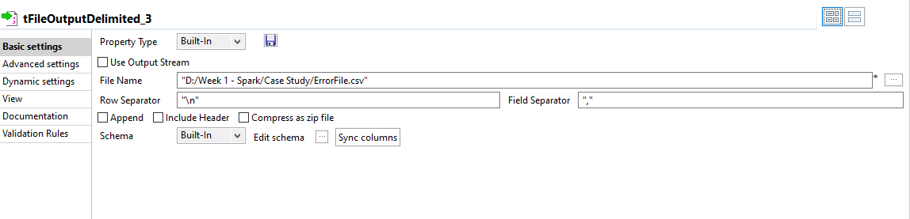

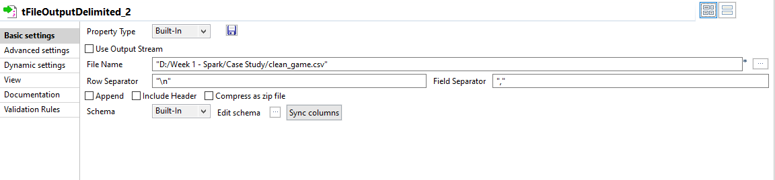

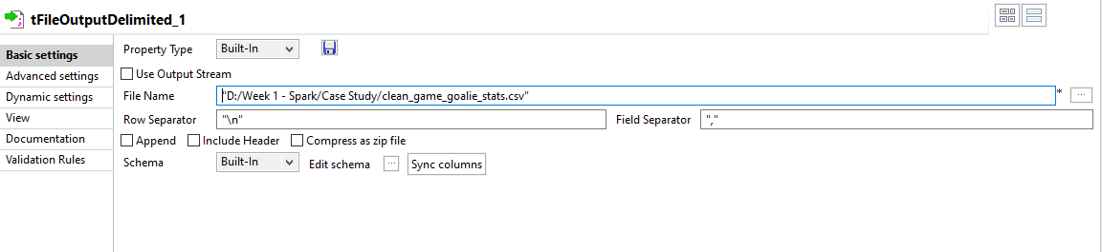

**Using spark**

**3) Quality checks and profiling (HiveQL)**

**Copying from local to hdfs (uncleaned datasets)**

hadoop fs -copyFromLocal "/home/user/Desktop/game.csv"

hadoop fs -copyFromLocal "/home/user/Desktop/gamegolie.csv"

Hadoop fs -ls

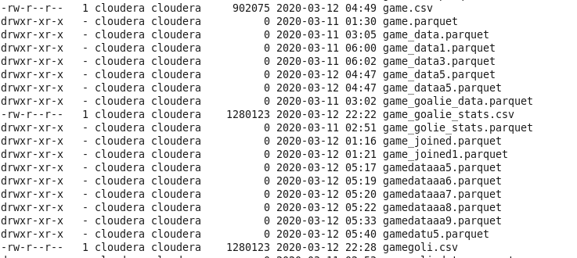

**Creating dataframe in spark**

**gamegoli.csv**

1. val gameGoali1 = sc.textFile("/user/cloudera/gamegoli.csv")
2. case class gamegolieDat1(game_id: Long,player_id: Long,team_id: Integer,timeonice: Long,assists: Integer,goals: Integer,pim: Integer,shots: Integer,saves: Integer,powerplaysaves: Integer,shorthandedsaves: Integer,evensaves: Integer,shorthandedshotsagainst: Integer,evenshotsagainst: Integer,powerplayshotsagainst: Integer,decision: String,savepercentage:String,powerplaysavepercentage: String,evenstrengthsavepercentage: String)
3. val mapGameGolieData5 = gameGoali1.map(_.split(",")).map(g => gamegolieDat1(g(0).toLong, g(1).toLong, g(2).toInt, g(3).toLong, g(4).toInt,g(5).toInt,g(6).toInt,g(7).toInt,g(8).toInt,g(9).toInt,g(10).toInt,g(11).toInt,g(12).toInt,g(13).toInt,g(14).toInt,g(15),g(16),g(17),g(18)))
4. val gameshiftsDataReadyy1 = mapGameGolieData5.toDF()
5. gameshiftsDataReadyy1.write.parquet("/user/cloudera/parquetfile3.parquet")
6. val gameDataRea = sqlContext.read.parquet("/user/cloudera/parquetfile3.parquet")

**game.csv**

1. val gameFile1 = sc.textFile("/user/cloudera/game.csv")
2. case class gameData3(game_id: Long, season: Long, game_type: String, date_time: String,away_team_id: Integer,home_team_id: Integer,away_goals: Integer,home_goals: Integer,outcome: String,home_rink_side_start: String,venue: String,venue_link: String, venue_time_zone_id: String, venue_time_zone_offset: Integer,venue_time_zone_tz: String)
3. val mapGameData = gameFile1.map(_.split(",")).map(g => gameData3(g(0).toLong,g(1).toLong,g(2),g(3),g(4).toInt,g(5).toInt,g(6).toInt,g(7).toInt,g(8),g(9),g(10),g(11),g(12),g(13).toInt,g(14)))
4. val gameDataReadyy = mapGameData.toDF()
5. gameDataReadyy.write.parquet("/user/cloudera/gameparquet12.parquet")
6. val gameDataReadyy1 = sqlContext.read.parquet("/user/cloudera/gameparquet12.parquet")

**Quality checks and profiling(Using Talend)**

**3) A) Finding null values and replace them**

val updatedDf = gameshiftsDataReadyy1.withColumn("powerplaysavepercentage", regexp_replace(col("powerplaysavepercentage"), "NA", "0"))

Loading to hive tables

updatedDf.registerTempTable("nullclean")

sqlContext.sql("create table casestudy.nullclean as select * from nullclean")

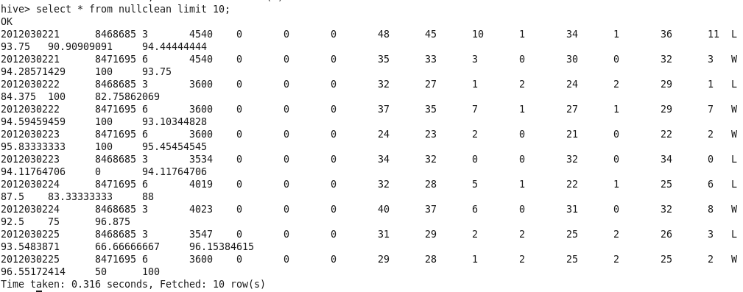

**3) b)Round off decimal values up to 2 places**

val upd= gameshiftsDataReadyy1.withColumn("savepercentage",round(gameshiftsDataReadyy1.col("savepercentage"),2))

upd.registerTempTable("doubleprecision")

sqlContext.sql("create table casestudy.doubleprecision as select * from doubleprecision")

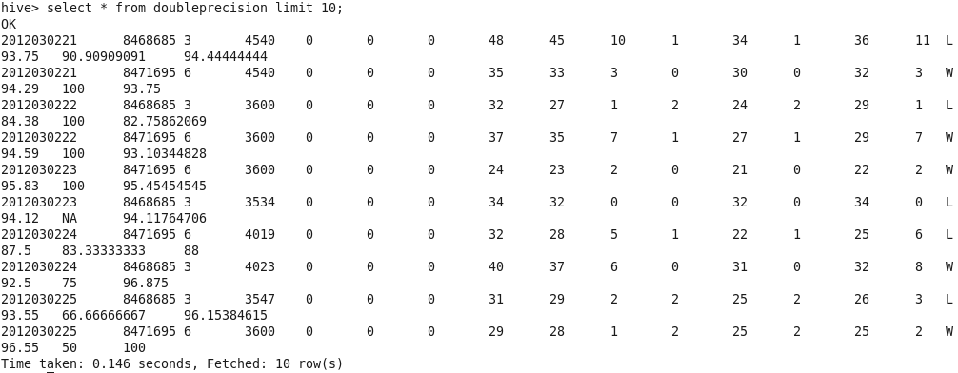

**4)Standardization (Date, Number)**

**4) A) Convert dates to “dd-mm-yyyy hh:mm:ss” format**

* val modify = gameDataReadyy.withColumn("date_time",date_format(unix_timestamp($"date_time","MM/dd/yyyy").cast("timestamp"),"dd-MM-yyyy HH:mm:ss"))
* gameDataReadyy.registerTempTable("datechange")
* sqlContext.sql("create table casestudy.datachange as select * from datachange"

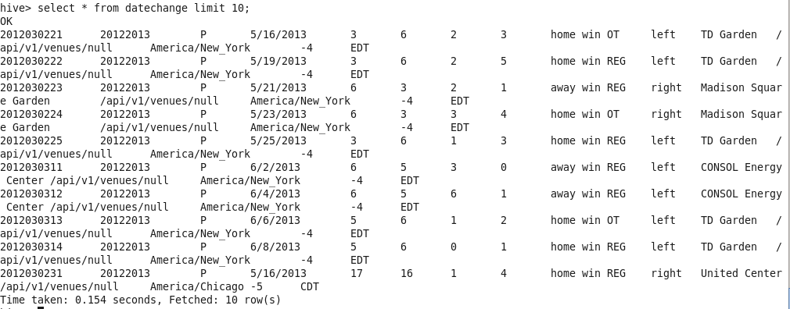

4)B)**Convert float to Integer**

val g1=gameDataRea.withColumn("evenstrengthsavepercentage",$"evenstrengthsavepercentage".cast("Int"))

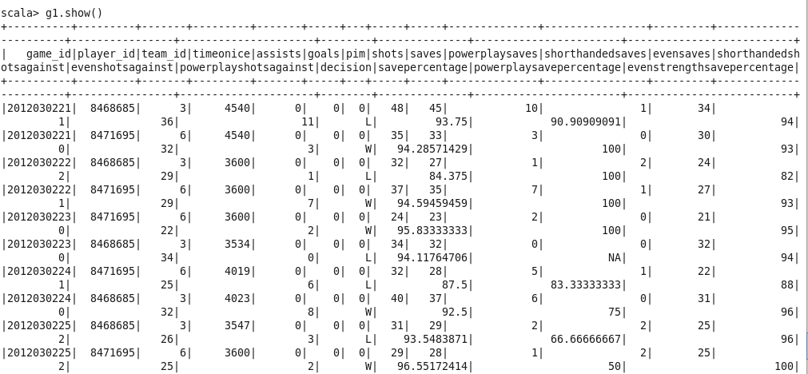

g1.registerTempTable("convert")

sqlContext.sql("create table casestudy.convert as select * from convert")

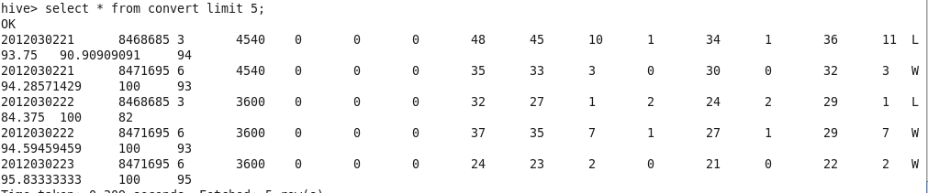

**5)** **Flattening-3 De-normalized tables (Data frames)**

**Copying from local to hdfs (cleaned datasets)**

clean_game.csv

hadoop fs -copyFromLocal "/home/user/Desktop/clean_game.csv”

clean_game_golie_stats.csv

hadoop fs -copyFromLocal "/home/user/Desktop/clean_game_golie_stats.csv”

game_skater_stats.csv

hadoop fs -copyFromLocal "/home/user/Desktop/game_skater_stats.csv

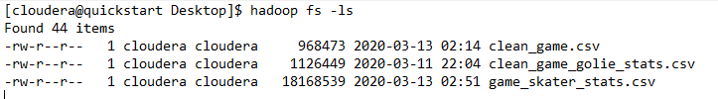

**Creating dataframe in spark and creating temp table in spark**

1) clean_game.csv

i) val gameFile = sc.textFile("/user/cloudera/game.csv")

ii) case class gameData(game_id: Long, season: Long, game_type: String, date_time: String,away_team_id: Integer,home_team_id: Integer,away_goals: Integer,home_goals: Integer,outcome: String,home_rink_side_start: String,venue: String,venue_link: String, venue_time_zone_id: String, venue_time_zone_offset: Integer,venue_time_zone_tz: String)

iii) val mapGameData = gameFile.map(_.split(",")).map(g => gameData(g(0).toLong,g(1).toLong,g(2),g(3),g(4).toInt,g(5).toInt,g(6).toInt,g(7).toInt,g(8),g(9),g(10),g(11),g(12),g(13).toInt,g(14)))

iv) val gameDataReady = mapGameData.toDF()

v) gameDataReady.write.parquet("/user/cloudera/game_data3.parquet")

vi) val gameDataReady = sqlContext.read.parquet("/user/cloudera/game_data3.parquet")

vii)gameDataReady.registerTempTable("game")

viii)sqlContext.sql("select * from game").show()

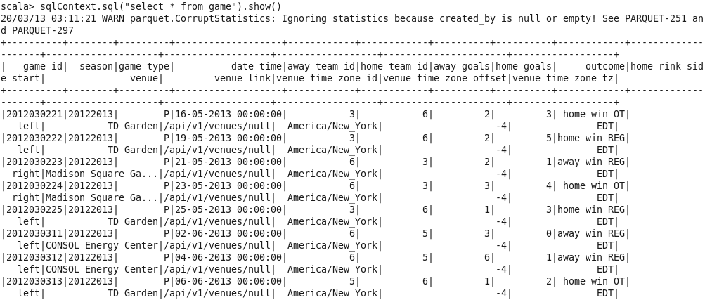

2) clean_game_golie_stats.csv

i) val gameGoalie = sc.textFile("/user/cloudera/clean_game_golie_stats.csv")

ii) case class gamegolieData(game_id: Long,player_id: Long,team_id: Integer,timeonice: Long,assists: Integer,goals: Integer,pim: Integer,shots: Integer,saves: Integer,powerplaysaves: Integer,shorthandedsaves: Integer,evensaves: Integer,shorthandedshotsagainst: Integer,evenshotsagainst: Integer,powerplayshotsagainst: Integer,decision: String,savepercentage:Float,powerplaysavepercentage: Float,evenstrengthsavepercentage: Float)

iii) val mapGameGolieData = gameGoalie.map(_.split(",")).map(g => gamegolieData(g(0).toLong, g(1).toLong, g(2).toInt, g(3).toLong, g(4).toInt,g(5).toInt,g(6).toInt,g(7).toInt,g(8).toInt,g(9).toInt,g(10).toInt,g(11).toInt,g(12).toInt,g(13).toInt,g(14).toInt,g(15),g(16).toFloat,g(17).toFloat,g(18).toFloat))

iv) val gameshiftsDataReady = mapGameGolieData.toDF()

v) gameshiftsdataReady.write.parquet("/user/cloudera/game_data.parquet")

vi) val gameshiftsDataReady = sqlContext.read.parquet("/user/cloudera/game_data.parquet")

vii)gameshiftsDataReady.registerTempTable("game_golie")

viii)sqlContext.sql("select * from game_golie").show()

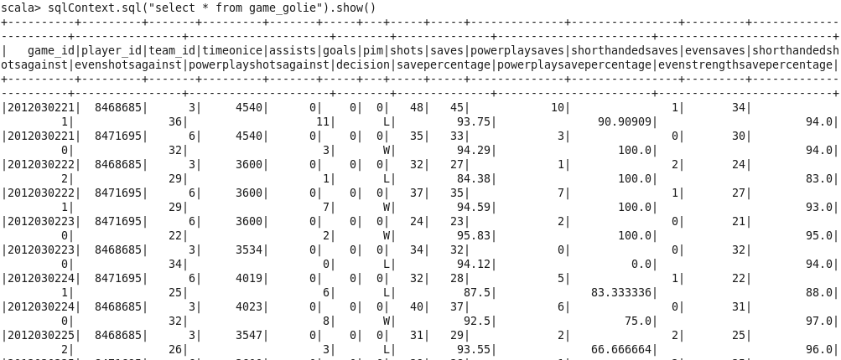

3) game_skater.csv

i)val gameskaterFile = sc.textFile("/user/cloudera/game_skater_stats.csv")

ii)case class teamInfo(game_id: Long,player_id: Long,team_id:Integer,timeonice: Long,assists:Integer,goals:Integer,shots:Integer,hits:Integer,powerplaygoals:Integer,powerplayassists: Integer,penaltyminutes: Integer,faceoffwins: Integer,faceofftaken: Integer,takeaways:Integer,giveaways: Integer,shorthandedgoals:Integer,shorthandedassists:Integer,bloacked: Integer,plusminus:Integer,eventimeonice:Integer,shorthandedtimeonice:Integer,powerplaytimeonice:Integer)

iii)val mapTeamInfo = gameskaterFile.map(_.split(",")).map(t => teamInfo( t(0).toLong, t(1).toLong, t(2).toInt, t(3).toLong, t(4).toInt, t(5).toInt,t(6).toInt,t(7).toInt,t(8).toInt,t(9).toInt,t(10).toInt,t(11).toInt,t(12).toInt,t(13).toInt,t(14).toInt,t(15).toInt,t(16).toInt,t(17).toInt,t(18).toInt,t(19).toInt,t(20).toInt,t(21).toInt))

iv)val teamInfoReady = mapTeamInfo.toDF()

v)teamInfoReady.write.parquet("/user/cloudera/team_info.parquet")

vi)val teamInfoReady = sqlContext.read.parquet("/user/cloudera/team_info.parquet")

vii)teamInfoReady.registerTempTable("gameskater")

viii)sqlContext.sql("select * from gameskater").show()

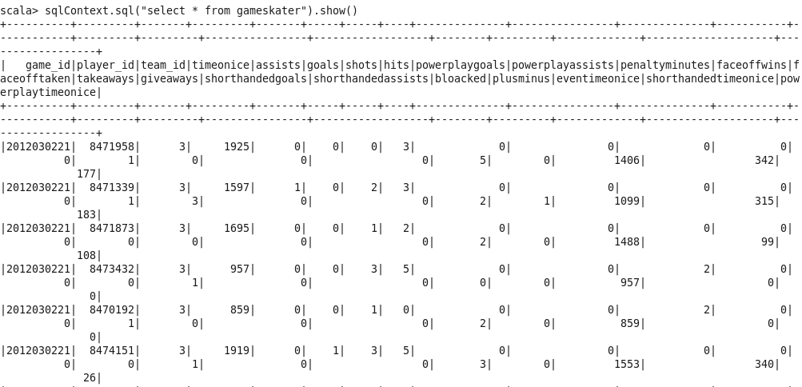

**Loading data into Hive table**

**Clean_game.csv**

* hiveContext.sql("CREATE TABLE casestudy1.game1(game_id bigint, season bigint, game_type String, date_time String,away_team_id int,home_team_id int,away_goals int,home_goals int,outcome String,home_rink_side_start String,venue String,venue_link String, venue_time_zone_id String, venue_time_zone_offset int,venue_time_zone_tz String) row format delimited fields terminated by ','");
* hiveContext.sql("LOAD DATA INPATH '/user/cloudera/clean_game.csv' INTO TABLE casestudy1.game1")

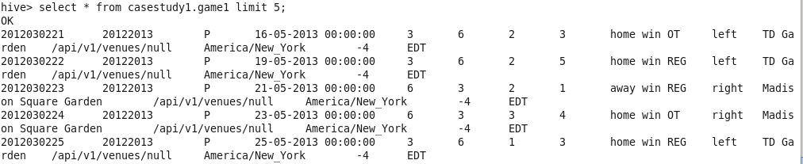

**clean_game_golie_stats.csv**

* hiveContext.sql("CREATE TABLE casestudy1.game_golie1(game_id bigint,player_id int,team_id int,timeonice bigint,assists int,goals int,pim int,shot int,saves int,powerplaysaves int,shorthandedsaves int,evensaves int,shorthandedshotsagainst int,evenshotsagainst int,powerplayshotsagainst int,decision String,savepercentage double,powerplaysavepercentage double,evenstrengthsavepercentage double) row format delimited fields terminated by ','");
* hiveContext.sql("LOAD DATA INPATH '/user/cloudera/clean_game_golie_stats.csv' INTO TABLE casestudy1.game_golie1")

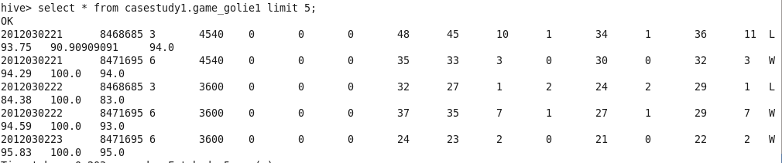

**game_skater_stats.csv**

* hiveContext.sql("CREATE TABLE casestudy1.game_skaters(game_id bigint,player_id bigint,team_id int,timeonice bigint,assists int,goals int,shots int,hits int,powerplaygoals int,powerplayassists int,penaltyminutes int,faceoffwins int,faceofftaken int,takeaways int,giveaways int,shorthandedgoals int,shorthandedassists int,bloacked int,plusminus int,eventimeonice int,shorthandedtimeonice int,powerplaytimeonice int) row format delimited fields terminated by ','")
* hiveContext.sql("LOAD DATA INPATH '/user/cloudera/game_skater_stats.csv' INTO TABLE casestudy1.game_skaters")

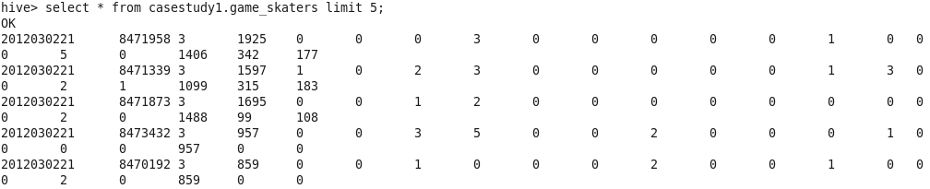

**Join the game LEFT JOIN game_goalie_stats RIGHT JOIN game_skaters**

i)val resf = gameDataReady.join(gameshiftsDataReady ,Seq("game_id"),"left")

ii) val leftTable = resf.select("season","game_type","home_team_id","venue","venue_time_zone_tz","venue_time_zone_id","outcome","player_id","savepercentage","decision","saves","shots","game_id")

iii) val skater = teamInfoReady.select("game_id","timeonice","goals","bloacked","powerplaytimeonice")

iv)val joinedDF = leftTable.join(skater,Seq("game_id"),"right")

v) val joinedDF_withDate = joinedDF.withColumn("current_date",lit(current_date())).withColumn("current_timestamp",lit(u nix_timestamp()))

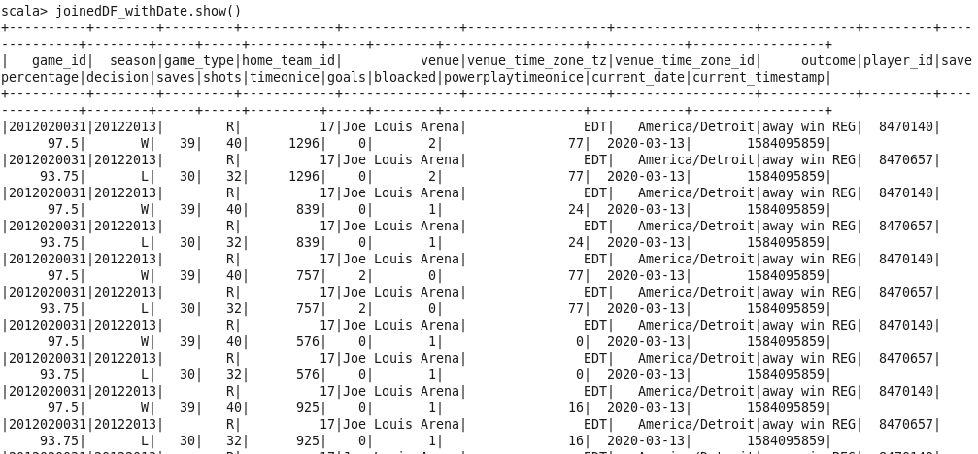

**Loading Joined Table to HIVE :**

joinedDF_withDate.registerTempTable("team_stats")

sqlContext.sql("create table casestudy.team_stats as select * from team_stats")

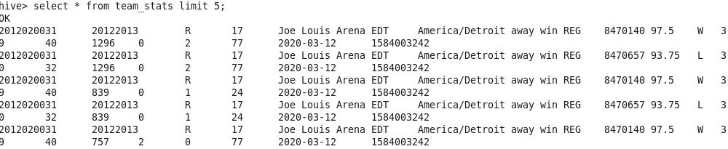

**6)** **Aggregations-5-6 aggregated tables (HiveQL)**

* hiveContext.sql("CREATE TABLE casestudy1.max_timeonice as select player_id,venue,venue_time_zone_tz,max(timeonice) from casestudy.team_stats group by player_id,venue,venue_time_zone_tz");

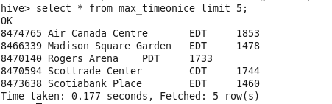

* hiveContext.sql("CREATE TABLE casestudy1.min_blocked as select player_id,season,savepercentage,min(bloacked) from casestudy.team_stats group by player_id,season,savepercentage");

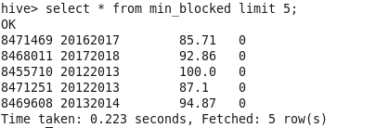

* hiveContext.sql("CREATE TABLE casestudy1.total_goals as select player_id,shots,outcome,sum(goals) from casestudy.team_stats group by player_id,shots,outcome");

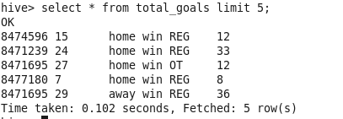

Select queries

---------------------------

1)Display the team_stats joined target table data.

hiveContext.sql("select * from casestudy.team_stats limit 10").show();

game_id| season|game_type|home_team_id| venue|venue_time_zone_tz|venue_time_zone_id| outcome|player_id|savepercentage|decision|saves|shots|timeonice|goals|bloacked|powerplaytimeonice|current_date|current_timestamp|

|2012020031|20122013| R| 17|Joe Louis Arena| EDT| America/Detroit|away win REG| 8470140| 97.5| W| 39| 40| 1296| 0| 2| 77| 2020-03-12| 1584003242|

|2012020031|20122013| R| 17|Joe Louis Arena| EDT| America/Detroit|away win REG| 8470657| 93.75| L| 30| 32| 1296| 0| 2| 77| 2020-03-12| 1584003242|

|2012020031|20122013| R| 17|Joe Louis Arena| EDT| America/Detroit|away win REG| 8470140| 97.5| W| 39| 40| 839| 0| 1| 24| 2020-03-12| 1584003242|

|2012020031|20122013| R| 17|Joe Louis Arena| EDT| America/Detroit|away win REG| 8470657| 93.75| L| 30| 32| 839| 0| 1| 24| 2020-03-12| 1584003242|

|2012020031|20122013| R| 17|Joe Louis Arena| EDT| America/Detroit|away win REG| 8470140| 97.5| W| 39| 40| 757| 2| 0| 77| 2020-03-12| 1584003242|

|2012020031|20122013| R| 17|Joe Louis Arena| EDT| America/Detroit|away win REG| 8470657| 93.75| L| 30| 32| 757| 2| 0| 77| 2020-03-12| 1584003242|

|2012020031|20122013| R| 17|Joe Louis Arena| EDT| America/Detroit|away win REG| 8470140| 97.5| W| 39| 40| 576| 0| 1| 0| 2020-03-12| 1584003242|

|2012020031|20122013| R| 17|Joe Louis Arena| EDT| America/Detroit|away win REG| 8470657| 93.75| L| 30| 32| 576| 0| 1| 0| 2020-03-12| 1584003242|

|2012020031|20122013| R| 17|Joe Louis Arena| EDT| America/Detroit|away win REG| 8470140| 97.5| W| 39| 40| 925| 0| 1| 16| 2020-03-12| 1584003242|

|2012020031|20122013| R| 17|Joe Louis Arena| EDT| America/Detroit|away win REG| 8470657| 93.75| L| 30| 32| 925| 0| 1| 16| 2020-03-12| 1584003242|

2)Display the game_id which is having away as string included in it.

hiveContext.sql("select game_id from casestudy.team_stats where outcome like 'away%' limit 10").show();

| game_id|

|2012020031|

|2012020031|

|2012020031|

|2012020031|

|2012020031|

|2012020031|

|2012020031|

|2012020031|

|2012020031|

|2012020031|

+----------+

3)Display game_type from joined target table for all the game players in 20122013.

hiveContext.sql("select game_type from casestudy.team_stats where season = 20122013 group by game_type ").show();

|game_type|

| P|

| R|

4)Display maximum save percentage from min_blocked table for each season

hiveContext.sql("select max(savepercentage) as savepercentage from casestudy1.min_blocked group by season").show()

|savepercentage|

| 100.0|

| 100.0|

| 100.0|

| 100.0|

| 100.0|

| 100.0|

5)Display all the venues having timezone 'EDT'

hiveContext.sql("select venue from casestudy1.max_timeonice where venue_time_zone_tz like 'EDT'").show()

| venue|

| Air Canada Centre|

|Madison Square Ga...|

| Scotiabank Place|

| BB&T Center|

|CONSOL Energy Center|

| Capital One Arena|

|Tampa Bay Times F...|

| Verizon Center|

| Citi Field|

| Wells Fargo Center|

| PNC Arena|

| Wells Fargo Center|

| Barclays Center|

| Amalie Arena|

| Nassau Coliseum|

|Canadian Tire Centre|

|Little Caesars Arena|

| Nassau Coliseum|

|Tampa Bay Times F...|

| Nassau Coliseum|

6)Display player_id in venue "PNC Arena"

hiveContext.sql("select player_id from casestudy1.max_timeonice where venue like 'PNC%'").show()

|player_id|

| 8475717|

| 8473575|

| 8460704|

| 8473607|

| 8477465|

| 8470594|

| 8473523|

| 8475852|

| 8455710|

| 8475839|

| 8476839|

| 8471239|

| 8470645|

| 8471774|

| 8473503|

| 8460703|

| 8474690|

| 8471219|

| 8469548|

| 8460535|

7)Display player_id who have shots greater than 20.

hiveContext.sql("select player_id from casestudy1.total_goals where shots>20").show()

|player_id|

| 8471239|

| 8471695|

| 8471695|

| 8462147|

| 8470657|

| 8471695|

| 8477293|

| 8471679|

| 8471679|

| 8476839|

| 8471774|

| 8471695|

| 8470657|

| 8470147|

| 8470320|

| 8475311|

| 8475852|

| 8475839|

| 8470657|

| 8471306|

**7) BI-Visualization (Excel)**

**clean_game.csv**

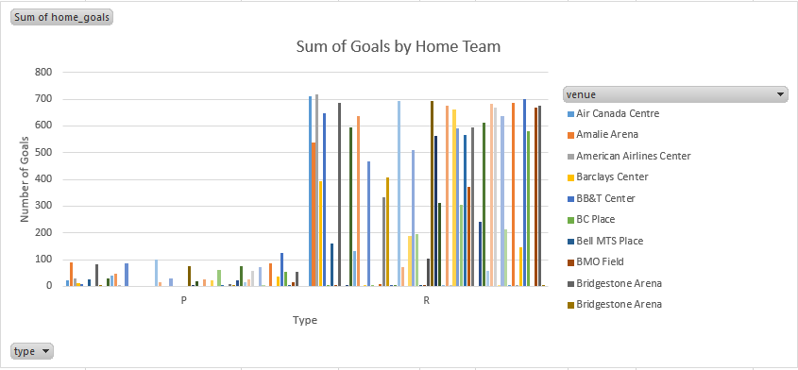

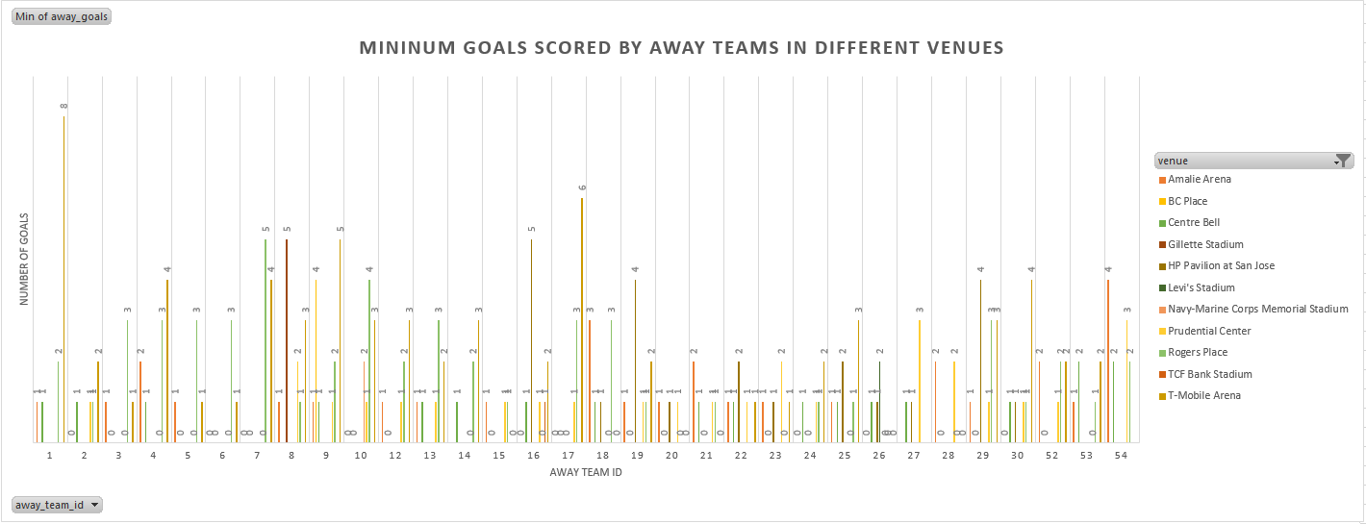

**clean_game_golie.csv**

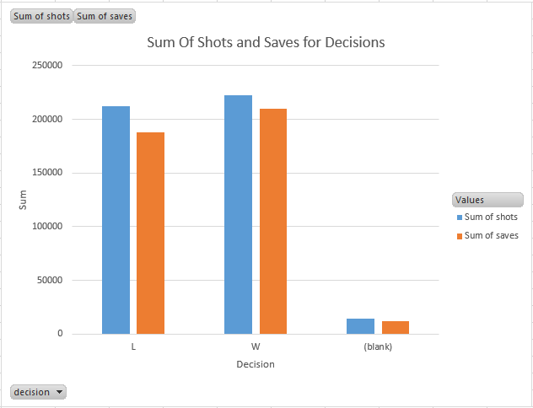

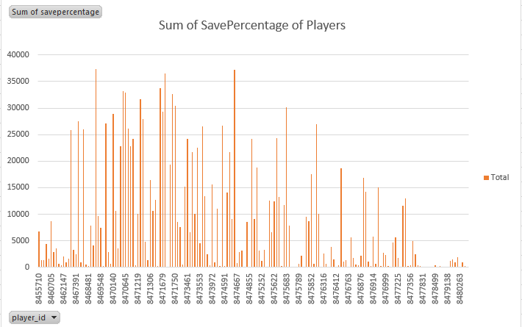

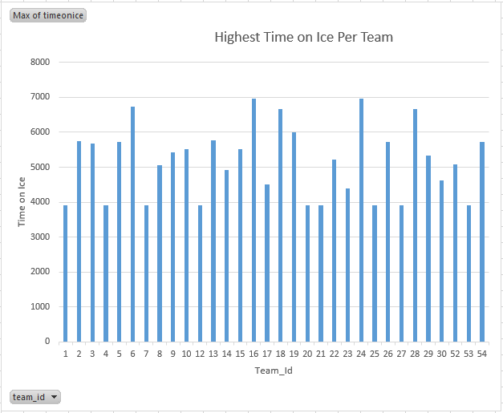

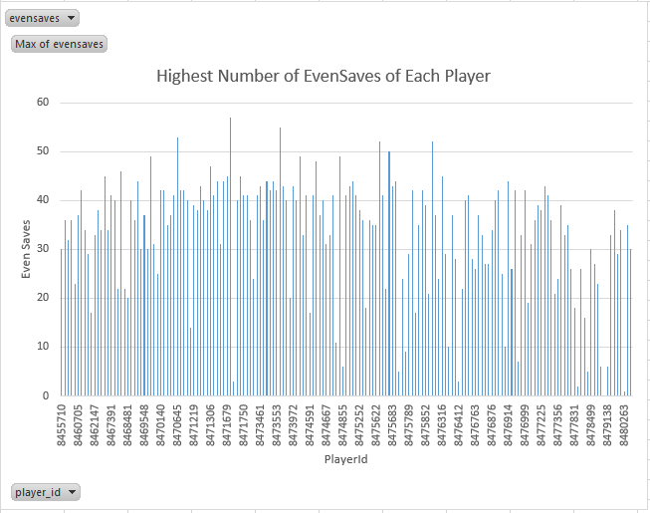

**game_skaters.csv**

